

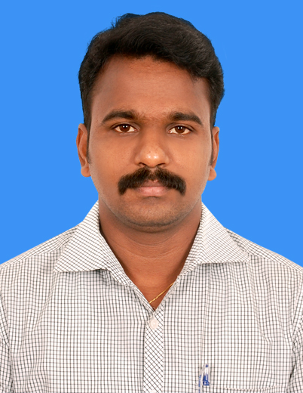

T.BOOVARAGA MOORTHY
H- 89, Tiruppur Kumaran II Lane,
MMDA Colony, Arumbakkam – 600 106
E-Mail: moorthy.chemical@gmail.com
moorthy_chemical@rediffmail.com
Mobile: +91-99400 85602

Career Objective:

- To become a leading Design Engineer in the Utility field which offers opportunity to learn and contribute in this field.

Academic Profile:

Bachelor of Technology in the field of Chemical Engineering at Priyadarshini Engineering College, affiliated to Madras University.

Exam Passed | Year | Institution | Board of Control | Percentage
Matriculation | 1995-1996 | Kamaraj Matriculation  Hr.Sec. School, Chidambaram | Matric Board | 77.01
Higher Secondary | 1996-1998 | R.C.T.Higher Sec.School,  Chidambaram. | State Board | 84.58
B.Tech  (Chemical) | 1998-2002 | Priyadarshini Engg  College, Vaniyambadi. | Madras University,  Chennai. | 75.33  (with distinction)
Diploma in Industrial Safety | 2002-2003 | Annamalai University | - | 75.2
Diploma In Petroleum Refining Engineering | 2013-2014 | Annamalai University | - | Passed

Extra-Curricular Activities:

- Project on “Study of Personnel Protective Equipment” – at Annamalai University
- One day Training Program on “Production, Planning & Control”, Chennai.

Software Skills:

- MS Office - Version 2007
- ROSA(Reverse Osmosis System Analysis) - Version 7.2.7
- Integrated Membrane Design (IMS) - Version 2012.8

Work Experience:
Bio Engineering Solutions, Chennai

Project Manager (Design & Proposals) Sep 2013 – till date
- A progressing & innovative project organization in the Environmental field.
- www.bioenggsolutions.com

Role & Responsibilities – Project Manager
Coordination/Review of design documents, Proposals & data sheets
Preparing & Design Verifications of Proposals
Process Equipment sizing,
Technical Meeting for Bid Proposals, Design Verification of Tender Documents

Eco Care Engineering Private Limited, Chennai

Project Manager (Design & Proposals) Aug 2011 – Aug 2013
- One of the rapid growing project organizations in the Environmental field.
- Turnkey projects on Water & Waste Water Treatment Plants.
- www.ecocareenggpvtltd.com

Role & Responsibilities – Project Manager (Design & Proposals)
Preparing & Design Verifications of Proposals
Technical Meeting for Bid Proposals, Design Verification of Tender Documents,
Site visits for plant Proposal & Layout Preparation, Power load & Chemical Injection Calculations, Designing Water Treatment equipments & RO systems by ROSA software tools.
Preparation of Water Balance, Pump Hydraulics & line sizing Calculations, Operation Control philosophy, Specification of Equipments & Bill of Quantities, Conducting Training Program for plant Commissioning, Preparation of Data Sheets.
Erection & Commissioning, Troubleshooting & Servicing
Preparation of Manuals & Handing over Reports & Client coordination
Basic Knowledge of Civil Works & execution.

Major Projects Handled:
M/s Caterpillar India Private Limited, Chennai – (STP/ETP/WTP – 45/70/80)
M/s Cosma International India Private Limited, Pune - (STP/ETP/WTP – 50/50/150 KLD)
M/s Cosma International India Private Limited, Chennai - (STP/ETP/WTP – 25/50/150 KLD)
M/s Hyundai Motors India limited, Irungattukottai – (ETP 360 KLD & WTP 350 KLD)
M/s Allison Transmission India Limited, Oragadam, Chennai (ETP – 150 KLD)
M/s Innogeocity (Oragadam City Developers Private Limited), Oragadam, Chennai – STP – 500 KLD
M/s Larsen & Toubro Limited – Service Centre, Kancheepuram – CETP – 20 KLD
M/s Deluxe Apartments buildings Company, Chennai (STP – 110 KLD, WTP – 120 KLD)

Concepts India Private Limited, Chennai

Project Engineer Feb 2007 to Aug 2011
- A leading manufacturer of Water & Waste water Treatment Plants.
- Company has Head Office at Navi Mumbai & Branch office at Baroda.
- Turnkey projects on Water & Waste Water Treatment Plants.
- www.conceptsindia.org

Role & Responsibilities – Project Engineer – Project & Proposals
Preparing, Design & Verifying Proposals with design calculations.
Technical Meeting for Bid Proposals, Design Verification of Tender Documents,
Project Execution, Mechanical Inspection & line sizing Calculations.
Site Selection, Suggestions on Layout, P&ID
Erection & Commissioning, Troubleshooting & Servicing
Conducting Training Program for plant commissioning,
Preparation of Manuals & Handing over Reports & Client coordination

- Deputed for Project Completion to Oman for 3 months & to Jordan for 2 months.

Eco Care Engineering Private Limited, Chennai

Site Engineer – CPCL, Chennai Aug 2006 to Jan 2007
Operation & Maintenance of STP/RO – 2.5 MGD

Pure Enviro Engineering Private Limited, Chennai

Process Engineer April 2003 to July 2006
Projects Handled
Chennai Petroleum Corporation Limited, Chennai – TTP/RO – STP/RO – 2.5 MGD
ETP - Toyota Kirloskar Motor Limited, Bangalore - Stabilized STP with ETP (100 m3/day)
ETP - Tamilnadu Petro products Limited, Chennai – ETP – (100 m3/hr)
ETP - Ford India Limited, Chennai - {STP (450 m3/day) combined with ETP (40 m3/day)}

Personal Profile:

Father’s Name : Mr.N.Thiruvanapurathu Karuppu
Date of Birth & Age : 18th March 1981 & 34 Years
Nationality & Religion : Indian & Hindu
Marital Status : Married
Languages Known : English, Tamil (R/W/S) Hindi(S)
Passport Number : E9165165 (expired on 28.05.2014)

Declaration:
I hereby declare that all the statement and information given by me are true, correct and complete to the best of my knowledge and belief.

Place: Chennai T. Boovaraga Moorthy

